**Assignment -3**

**Bucket And Watson assistant**

|  |  |
| --- | --- |
| Assignment Date | 26 October 2022 |
| Student Name | Atchayha P M |
| Student Roll Number | 713319EC014 |
| Maximum Marks | 2 Marks |

**Questions:**

**1.Create a Bucket in IBM object storage.**

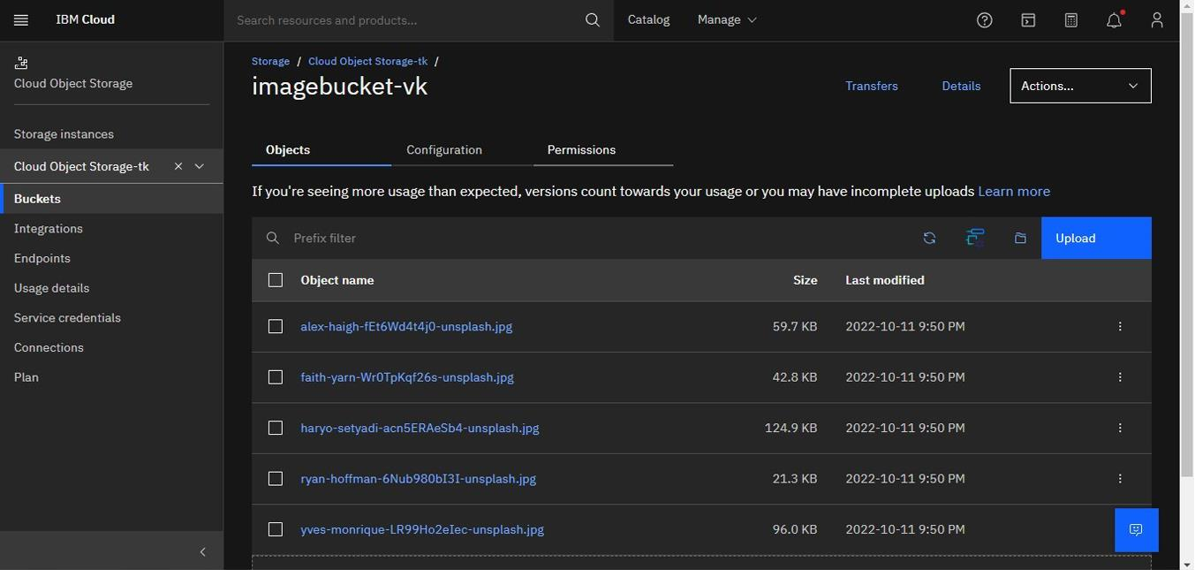

**2.Upload an 5 images to ibm object storage and make it public. write html code to displaying all the 5 images.**

**Index.html**

|  |
| --- |
| <!DOCTYPE *html*>  <html *lang*="en">    <head>  <meta *charset*="UTF-8">  <meta *http-equiv*="X-UA-Compatible" *content*="IE=edge">  <meta *name*="viewport" *content*="width=device-width, initial-scale=1.0">  <title>Smart Fashion shop </title>  <style> body {  background-color: aqua; display: flex; align-items: center; justify-content: center; flex-direction:  column; |

|  |
| --- |
| }  img { height: 240px; border-radius: 10px; margin: 10px;    }  </style>  </head>    <body>  <h1>Wellcom To Fashion Store</h1>  <div>  <img *src*="https://imagebucket-vk.s3.ap.cloudobjectstorage.appdomain.cloud/alex-haigh-fEt6Wd4t4j0-unsplash.jpg" *alt*="Dress" *srcset*="">  <img *src*="https://imagebucket-vk.s3.ap.cloudobjectstorage.appdomain.cloud/faith-yarn-Wr0TpKqf26s-unsplash.jpg" *alt*="Dress" *srcset*="">  <img *src*="https://imagebucket-vk.s3.ap.cloudobjectstorage.appdomain.cloud/haryo-setyadi-acn5ERAeSb4-unsplash.jpg" *alt*="Dress" *srcset*="">  <img *src*="https://imagebucket-vk.s3.ap.cloudobjectstorage.appdomain.cloud/ryan-hoffman-6Nub980bI3I-unsplash.jpg" *alt*="Dress" *srcset*="">  <img *src*="https://imagebucket-vk.s3.ap.cloudobjectstorage.appdomain.cloud/yves-monrique-LR99Ho2eIec-unsplash.jpg" *alt*="Dress" *srcset*="">  </div>    </body>  </html> |

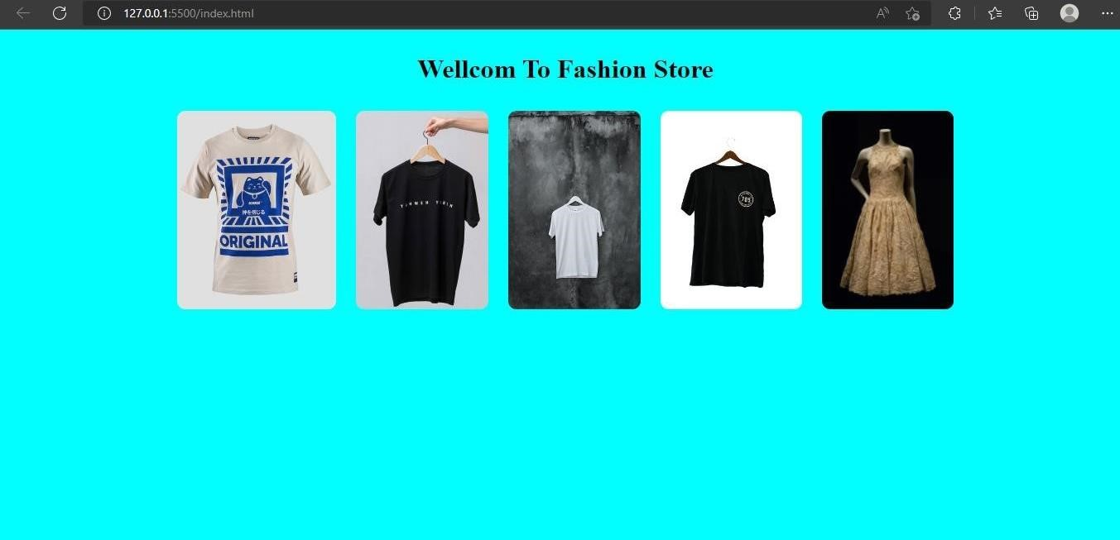

**3.Upload a css page to the object storage and use the same page in your HTML code.**

<!DOCTYPE *html*>

<html *lang*="en">

<head>

<meta *charset*="UTF-8">

<meta *http-equiv*="X-UA-Compatible" *content*="IE=edge">

<meta *name*="viewport" *content*="width=device-width, initial-scale=1.0">

<title>Smart Fashion shop </title>

<link *rel*="stylesheet" *href*="https://imagebucket-vk.s3.ap.cloudobjectstorage.appdomain.cloud/style.css">

</head>

<body>

<h1>Wellcom To Fashion Store</h1>

<div>

<img *src*="https://imagebucket-vk.s3.ap.cloudobjectstorage.appdomain.cloud/alex-haigh-fEt6Wd4t4j0-unsplash.jpg" *alt*="Dress" *srcset*="">

<img *src*="https://imagebucket-vk.s3.ap.cloudobjectstorage.appdomain.cloud/faith-yarn-Wr0TpKqf26s-unsplash.jpg" *alt*="Dress" *srcset*="">

<img *src*="https://imagebucket-vk.s3.ap.cloud-

objectstorage.appdomain.cloud/haryo-setyadi-acn5ERAeSb4-unsplash.jpg" *alt*="Dress" *srcset*="">

<img *src*="https://imagebucket-vk.s3.ap.cloud-

objectstorage.appdomain.cloud/ryan-hoffman-6Nub980bI3I-unsplash.jpg" *alt*="Dress" *srcset*="">

<img *src*="https://imagebucket-vk.s3.ap.cloudobjectstorage.appdomain.cloud/yves-monrique-LR99Ho2eIec-unsplash.jpg" *alt*="Dress" *srcset*="">

</div>

</body>

</html>

**Output:-**



**4.Design a chatbot using IBM Watson assistant for hospital. Ex: User comes with query to know the branches for that hospital in your city. Submit the web URL of that chat bot as a assignment.**

**Url :**[**- chatbot link**](https://web-chat.global.assistant.watson.appdomain.cloud/preview.html?backgroundImageURL=https%3A%2F%2Feu-gb.assistant.watson.cloud.ibm.com%2Fpublic%2Fimages%2Fupx-2187bdc6-3463-4336-a0e5-105ac4d979db%3A%3A31897cd3-e620-4527-80d8-c93d7c618899&integrationID=fd3649a9-27f7-43a9-96c0-5ca4d5bbf885&region=eu-gb&serviceInstanceID=2187bdc6-3463-4336-a0e5-105ac4d979db) **<- click**

**Image-**

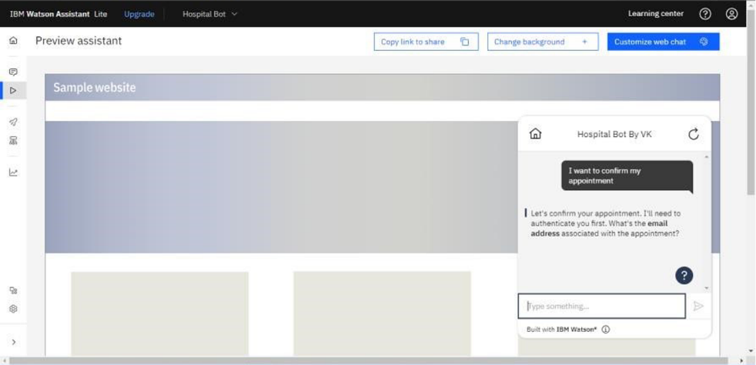

**5 .Create Watson assistant service with 10 steps and use 3 conditions in it. Load that script in HTML page**

